14.DFA -AAAB

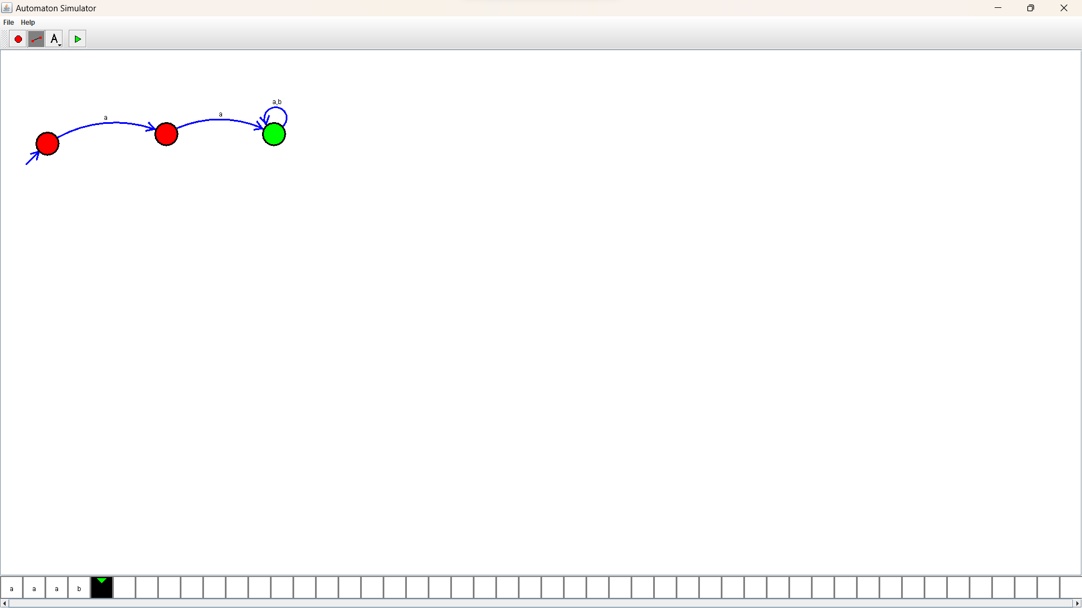Design :

Output :